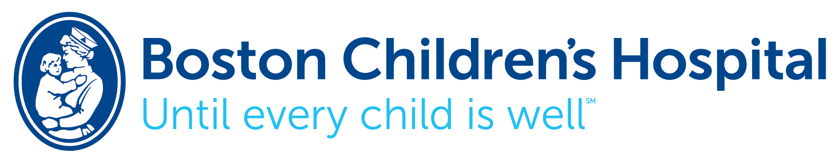

Child & Adolescent Psychiatry
Fellowship Program

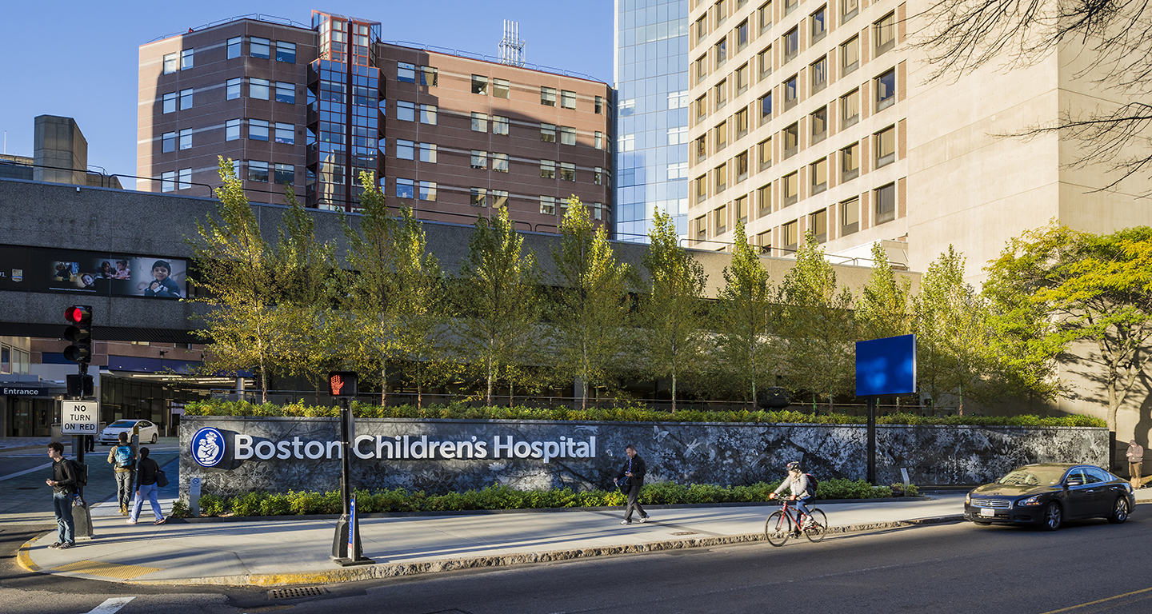

Our program goal is to prepare the next generation of leaders in behavioral health care;
and to support trainees and staff in delivering
the highest quality of care.

BOSTON CHILDREN’S HOSPITAL
U.S. News & World Report has ranked Boston Children’s Hospital as the premier pediatric hospital for the past six consecutive years. We are Harvard Medical School’s primary pediatric teaching hospital, and home to the world's largest research enterprise based at a pediatric medical center.
Boston Children’s Hospital (BCH) is a 404-bed comprehensive center for health care. As one of the largest pediatric medical centers in the United States, we offer a complete range of health care services for children from birth through 21 years of age, although some services can begin at 15 weeks gestation and extend into adulthood for many chronic childhood illnesses.
With a medical staff of nearly 1,100 faculty members, almost 1,000 trainees and over 1,500 nurses, BCH handles some 25,000 inpatient admissions and close to 557,000 clinic visits each year. Our research community hosts more than 1,100 scientists, including nine members of the National Academy of Sciences, 11 staff members of the Institute of Medicine and nine members of the Howard Hughes Medical Institute.
Our International Center welcomes patients from more than 100 countries to include services such as: coordination of visits, medical record keeping, immigration, interpretation, travel and accommodation arrangements.
Boston Children's Hospital has a long history of innovation dating back to 1891 with the nation’s first laboratory for the production of bacteria-free milk; the launch of pediatric surgery in 1920; Dr. Sidney Farber’s work in the late 1940’s which produced the world’s first partial remission of acute leukemia; in 1999 our Advanced Fetal Care Center was established for prenatal or immediate postpartum surgical intervention and America’s first Transgender Clinic for children was founded in 2007, to name but a few milestones.
More remarkably our faculty include two Nobel Prize winners: Dr. John Enders and colleagues who successfully cultured the polio virus paving the way for the Salk and Sabin vaccines, and Dr. Joseph Murray whose research focused on immuno-suppression, specifically in organ and cell transplantation.

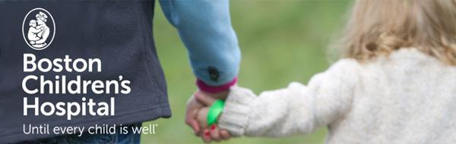

THE DEPARTMENT OF PSYCHIATRY

OUR VISION
Working together to help children and families achieve healthy development.

OUR MISSION
Promoting the well being of children and families through excellence in behavioral health care, education, innovation, and advocacy.

OUR EDUCATION PRIORITIES
To prepare the next generation of leaders in behavioral health care and to support trainees and staff in learning how to deliver the highest quality care.

OUR DEPARTMENT OVERVIEW
The Department of Psychiatry is focused on the development and implementation of a responsive behavioral health care continuum so as to provide children and adolescents with the right services in the right setting at the right time. As a way to determine the most effective care setting, the department has embraced a stepped-care approach to mental health care, whereby patients are grouped into mild, moderate, or severe levels of functioning. We know that the establishment of a productive treatment plan will require successful collaborative partnerships with primary care providers, school professionals, and community mental health providers.

Our department research is focused on understanding, diagnosing, and treating children at risk for mental health problems. Our research efforts integrate psychiatry, neuroscience, genetics, stem cell science, bioinformatics, and brain imaging with a goal of unlocking psychiatric disease through early detection, prevention, and intervention to protect and treat the most vulnerable community of children and young adults.

The department has been committed to educating the next generation of child and adolescent psychiatrists, clinical child psychologists, and psychiatric social workers. The department advocates at national, regional and local levels for the highest quality mental health services for children and families.

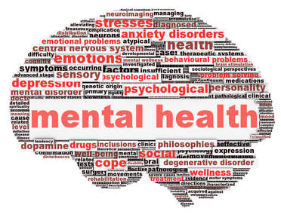

OUR CHAIRMAN

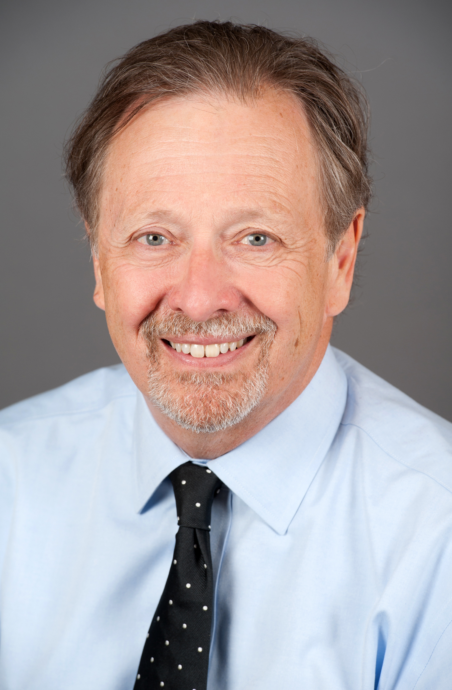
David R. DeMaso, MD
Psychiatrist-in-Chief and Chairman of Psychiatry,
Leon Eisenberg Chair in Psychiatry at Boston Children’s Hospital;
Gardner - Monks Professor of Child Psychiatry,
Professor of Pediatrics at Harvard Medical School

“Each and every day I am guided by the memory of my mentor,
Dr. Leon Eisenberg, who argued for the significance of biological context long before others, argued for the significance of social context when others found biological context, and mentored colleagues across the globe regarding the importance of returning humanism to the field of medicine. As psychiatrist-in-chief and chairman, I work to instill this same approach to our faculty and the next generation of child and adolescent psychiatrists that
join us each year.”

As a child and adolescent psychiatrist, the underlying essence of Dr. DeMaso’s work has been to understand what facilitates or hinders an individual's ability to cope with adversity. His career has encompassed research, administration, and advocacy. He has authored over 220 papers and chapters reporting the findings from his clinical and research innovations, including two textbooks on pediatric psychosomatic medicine (Textbook of Pediatric Psychosomatic Medicine and Clinical Manual of Pediatric Psychosomatic Medicine) and multiple chapters on pediatric behavioral health in leading textbooks, including the Nelson Textbook of Pediatrics and Mental Health Care of Children and Adolescents – A Guide for Primary Care Clinicians.

Dr. DeMaso has held top leadership positions at the American Academy of Child and Adolescent Psychiatry, has earned multiple awards from AACAP for his clinical, educational, research, and advocacy efforts in child mental health (Simon Wile Leadership in Consultation Award, Outstanding Mentor Award, Klingenstein Third Generation Foundation Award for Research in Depression or Suicide, Catcher in the Rye Advocacy Award), and has earned the honor of Distinguished Life Fellow of AACAP.

He completed his pediatric internship at Massachusetts General Hospital, his general psychiatry training at Duke University Medical Center, a child and adolescent psychiatry residency at Judge Baker Guidance Center - Children’s, and lastly a pediatric psychosomatic medicine fellowship at Boston Children’s Hospital.

OUR TRAINING DIRECTORS

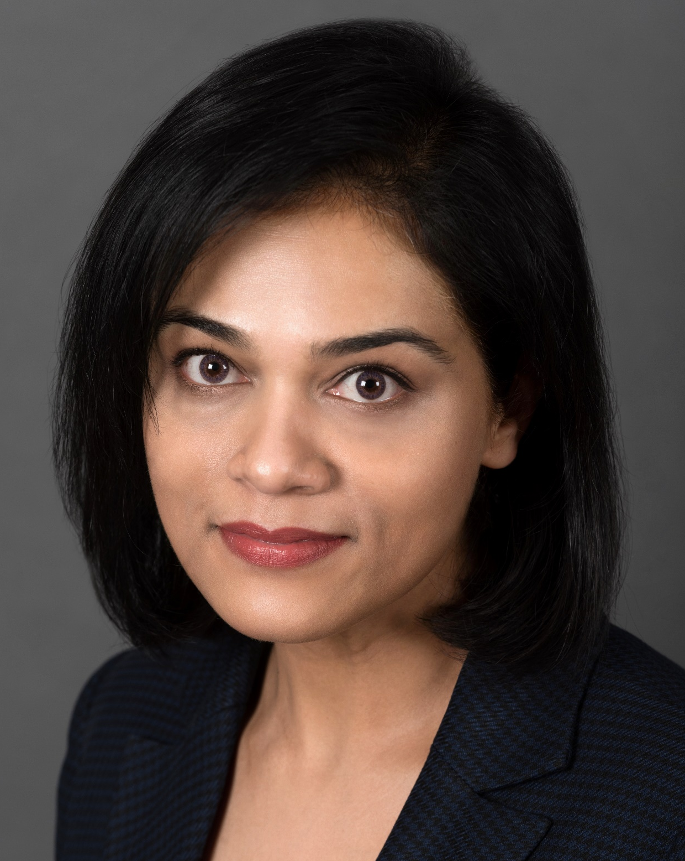

Zheala Qayyum, MD, MMSc
Training Director, Boston Children’s Hospital
Instructor in Psychiatry, Harvard Medical School

“It is indeed a great privilege to be able to bring the joy of play, curiosity and passion not just into our learning about children and adolescents, but also in our teaching. We hope to foster exceptional clinical skills and thoughtful inquiry in a magnitude of diverse settings, not only to develop well rounded Child and Adolescent Psychiatrists but also develop their particular areas of interest. Our mentors take great pride in investing in our learners so we can bring about the best care for our patients and their families.”

Dr. Zheala Qayyum is the medical director of the Emergency Psychiatry Services at Boston Children’s Hospital, and a medical educator. She is board certified in general psychiatry, child and adolescent psychiatry and consultation liaison psychiatry. She received her master’s degree in Medical Education from Harvard Medical School.

Dr. Qayyum’s clinical interests lie in acute psychiatric care as well as psycho-oncology and palliative care. However, she is most passionate about teaching. She supervises the Emergency Psychiatry rotation where in addition to teaching that is focused on diagnostic evaluations and risk assessments, she prioritizes the practice of biopsychosocial formulations.

Her medical education research focuses on the supervision and mentoring of trainees and finding creative ways to make medical education more engaging for the learners. Her clinical publications include acute psychiatric care of early psychosis, transitional age youth, and creating a gender-affirming environment for LGBTQ youth.

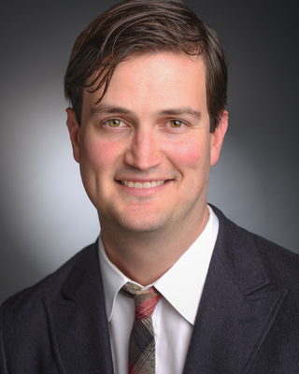

Chase Samsel, MD
Associate Fellowship Director, Boston Children’s Hospital
Medical Director, Psychiatry Consultation Service, Boston Children’s Hospital
Assistant Professor of Psychiatry, Harvard Medical School

“Child and Adolescent Psychiatry (CAP) training is critical in providing patients, families, teams, and systems with strong clinicians, team members, and leaders. CAPs provide relief to workforce shortages wherever they go and must be dynamic with a diverse skillset to make the most difference in the lives of children and families. Our first year of training provides a great foundation in outpatient and acute psychiatry, while work in the second year hones skills and empowers individuals in their specific niche interests, with an incredible array of flexible electives.”

Dr. Samsel is an attending psychiatrist and psychosocial oncologist on the Psychiatry Consultation Service (PCS), Pediatric Transplant Center, and the Dana Farber/Boston Children’s Cancer and Blood Disorders Center. He completed his pediatrics, adult psychiatry, and child psychiatry training at Brown University’s Triple Board Program and is board certified in all three specialties. On PCS, Dr. Samsel teaches and supervises Child and Adolescent Psychiatry Fellows, Psychology Postdoctoral Fellows, Psychology Interns, and Medical Students in addition to running the service. As part of his expertise in interdisciplinary care and systems work, Dr. Samsel has developed a curriculum to train fellows on adult learning, communication, and effective teaching. He also directs the Transition to Practice seminar taught during the second year of training, with seminars in physician personal finance literacy, private practice and “side-gigs”, job searches and negotiations, among other topics.

The majority of his scientific contributions to date, have been in the psychiatric care of seriously medically ill children and their families, and in the interface of pediatric and psychiatric care. He also teaches at Harvard Medical School in the pediatric rotation block and is the Co-Faculty Mentor for Child Psychiatry in the the Psychiatry Student Interest Group at Harvard Medical School.​

OUR CHILD AND ADOLESCENT PSYCHIATRY FELLOWSHIP
Our philosophy is that medical education is a graduated process during which child and adolescent psychiatrists, over a period of several years, gain experience with, and assume responsibility for, increasingly difficult patients and problems within their area of expertise. At the conclusion of training, fellows must be prepared to practice independently. We must train child and adolescent psychiatrists who by their final year of training are prepared to manage complex patients and problems. Performance evaluation and feedback is critical in helping fellows manage progressively more difficult problems, so that they will be able to function independently after graduation; only then will we have served the public in our training mission.
We provide timely, relevant instruction and supervision around the fundamentals of child and adolescent psychiatry that fosters the growth of each fellow as a developing professional, while acknowledging the challenges of entering a new field.
Our faculty offers hands-on supervision when and where it is needed, taking full advantage of critical teaching moments, and our program flexes to allow increasing autonomy as each fellow demonstrates their emerging competencies.

We want our fellows to develop skills to:
- Reduce the burden of suffering, and improve the quality of life for children and families that face disabling mental illnesses.
- Hone their evaluation artistry by identifying strengths and deficits of children and their families.
- Develop proficiency in both psychotherapies and somatic therapies.
- Treat child psychopathology in a bio-psycho-social context of development.
- Emphasize culturally competent and family-centered care.
- Explore community-based settings systems of care.
- Advocate for youth and their families.
- Develop leadership expertise and work effectively in interdisciplinary teams.

The Fellowship is structured so that the majority of required ACGME training experiences are completed in the first year, allowing substantial discretionary time in the second year for personal pursuits whether clinical, educational, or investigative. Our fellows are encouraged and supported to follow their interests and passions in the field of child and adolescent psychiatry.

Boston Children’s Hospital Child and Adolescent Psychiatry Fellowship program has graduated over 300 psychiatrists who have gone on to successful careers in advocacy, clinical, educational, administrative, and research realms. We are strongly committed to training the next generation of child and adolescent psychiatrists who will work in the nation’s evolving health care system to treat children and families.

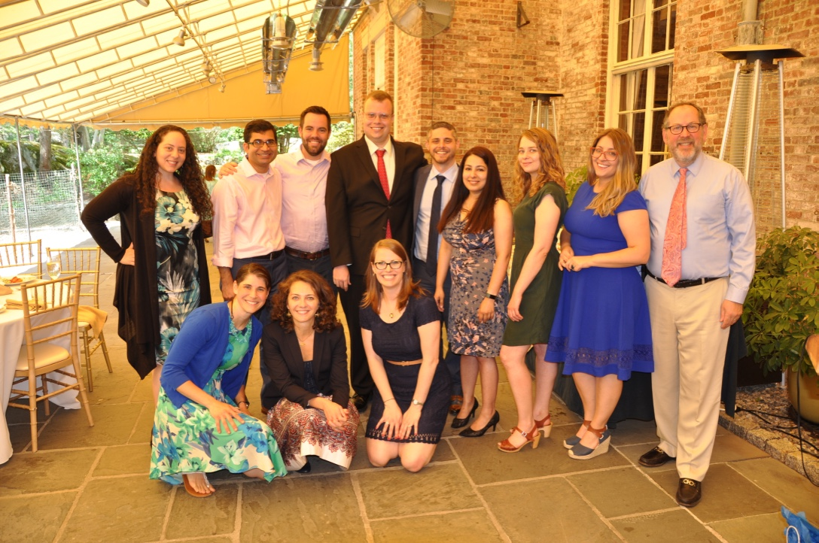
Fellows Class of 2018 & 2019
Back row (left to right): Jessica Bayner, Muhammad Zeshan, Jacob White,
Kyle Stephens, Gino Mortillaro, Vyoma Acharya, Amanda Schlesigner,
Martha Ignaszewski, Oscar Bukstein, Training Director
Front row: Tamar Katz, Eleni Maneta, Associate Training Director and Paige Partain

CHILD & ADOLESCENT FELLOWSHIP PROGRAM DESCRIPTION

The BCH CAP Fellowship is a traditional two-year fellowship, following three or four years of general (adult) psychiatry training, which is required for CAP Board Certification.

We have 6 fellowship positions each year.

YEAR I OUTLINE
- 2 months Inpatient Psychiatry Service & 2 months Emergency Department
- 4 months Psychiatry Consultation
- 4 months Outpatient Psychiatry Services

Inpatient Psychiatry Service and Emergency Department (IPS, ED) The unique training goals of the IPS/ED rotation are to teach fellows to evaluate and manage children, adolescents, and their families, who present with severe psychiatric illnesses, or co-morbid medical-psychiatric illnesses, requiring acute care or care in a more restrictive inpatient setting. In this rotation, our fellows work collaboratively with a multidisciplinary team, and are involved in all aspects of patient care, from family, to individual, to pharmacotherapy. During this block, fellows receive supervision from the medical director, the attending psychiatrists and social work staff; rotation-specific didactics are also provided. A dedicated resource specialist is available to assist in planning for aftercare in the Emergency Room, and discharge planning from the inpatient psychiatric service, so that fellows can focus on clinical care and learning. The trainees also have the opportunity to provide supervision and peer mentoring to junior trainees in the ED.

Psychiatry Consultation Service (PCS) The training goals of the PCS rotation are similar to those of IPS but in a less-restrictive inpatient setting. Working on the interface between psychiatry and pediatrics, challenges our fellows to refine their differential diagnostic and systems-management skills, as well as to develop and implement comprehensive treatment plans in a non-psychiatric milieu. During this four-month rotation our fellows work closely with their attending PCS staff member to evaluate and follow patients during their medical hospitalization. Rotation-specific didactics are also provided. And like IPS, a dedicated resource specialist is available to assist in planning for follow-up care following discharge from the medical service.

Outpatient Psychiatry Service (OPS) The unique training goals of the OPS are to teach fellows to conduct comprehensive evaluations, and to formulate and carry out related evidence-based treatment plans for children, adolescents, and their families who present with a wide range of psychiatric needs. Fellows perform clinical duties and train in a variety of outpatient settings: the Emergency Department, our Adolescent Substance Abuse Program, Pediatric Neurology, Gender Management Service, Center on Media and Child Health, Neuropsychiatry Clinic, our Pediatric Diagnostic Program and the Martha Eliot Community Health Center. Throughout the course of the first year, fellows maintain a continuity clinic one afternoon each week in the OPS. Attending supervisors review cases individually with each fellow in a traditional supervisory format; supervisors also directly observe and assist in select evaluations and/or follow-up appointments.

YEAR II OUTLINE
- Outpatient Psychiatry Service - three sessions/week
- Family Therapy/Group Therapy - one afternoon/week
- Inpatient Psychiatry Service – two months
- Elective

By the second year of training we expect our fellows to show increasing autonomy and independence in their competencies as child psychiatrists, yet we continue to provide an experiential teaching model where senior staff are present and available on-site to jointly see patients and families. The second year is designed to build upon the core skills and competencies required by ACGME, whilst also preparing them for graduation.

Given that the majority of the core training requirements are fulfilled during the first year of fellowship, one capstone of our program is that second year fellows have ample time to pursue specific, individualized areas of interest. This allows our fellows to uniquely tailor a majority of their second academic year to meet their own clinical, academic and professional goals.

On the Outpatient Psychiatry Service, second year fellows increase their clinical time to two clinical sessions per week. Fellows broaden their developing skills of assessment, psychotherapy and pharmacotherapy by working with a wider range of patients; supervisory structure is the same as that for the first year. During the course of the second year, each fellow also participates in a family therapy experience.

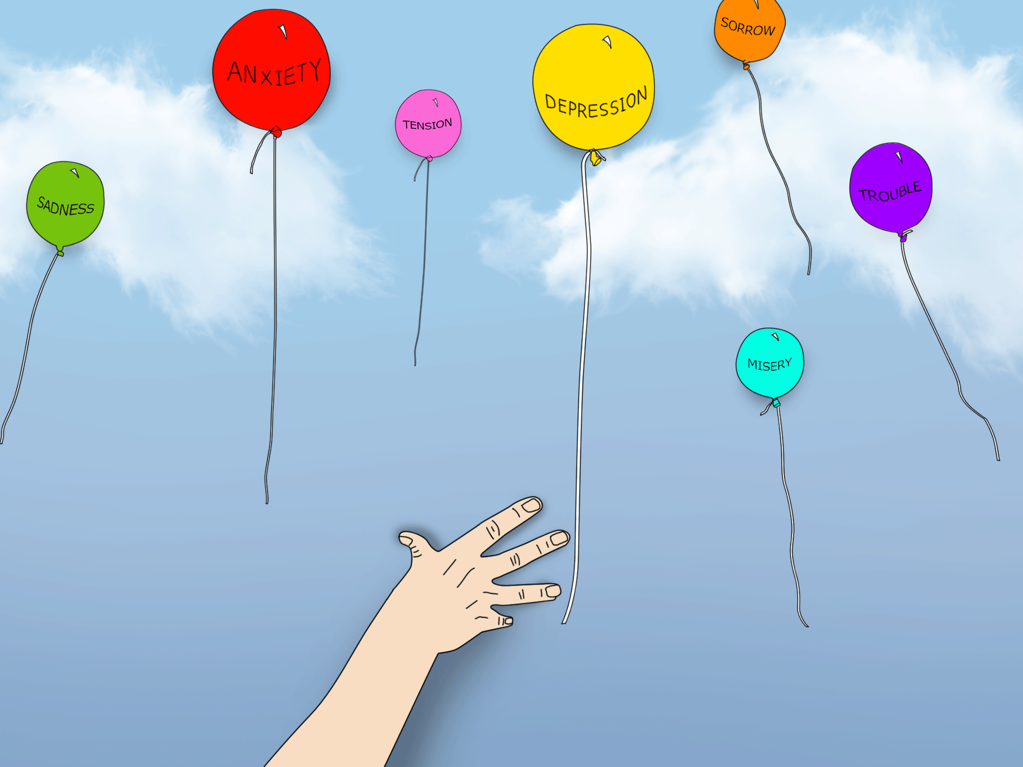

Both classes of fellows receive a forensic experience by participating in a Mock Trial event with retired lawyers, judges and postdoctoral fellows familiar with the Massachusetts legal system and matters related to the mental health needs of delinquent youth. They also get further exposure through the Department of Youth services in Massachusetts.
Boston Children's Hospital CAP 1 Rotation Blocks
 | MONDAY | TUESDAY |  | WEDNESDAY |  | THURSDAY | FRIDAY
AM | Rotation | Rotation |  | Rotation |  | All HMS CAP 1s | Rotation
 |  |  |  |  |  | Lecture Series
 |  |  |  | Grand Rounds |  | McLean Hospital
 |  |  |  | Morbidity & Mortality |  |  | Journal Club
 |  |  |  | T Group |  |  | Fellows Meeting
PM | Supervision | Psychotherapy |  | Psychopharmacology |  | Supervision | Diversity Lectures
 |  | Didactic |  | Didactic
 | Rotation | Rotation |  | Rotation |  | Outpatient Clinic | Rotation
 |  |  |  |  |  | Continuity
Boston Children's Hospital CAP 2 Rotation Blocks
 | MONDAY |  | TUESDAY |  | WEDNESDAY | THURSDAY | FRIDAY
AM | Elective |  | Elective |  | Elective | Elective | Elective
 |  |  | Outpatient Clinic |  | Grand Rounds
 |  |  | INTAKE |  | Morbidity & Mortality |  | Journal Club
 |  |  |  |  | Psychopharmacology |  | Fellows Meeting
PM | Supervision |  | Psychotherapy |  | Didactic | Supervision | Diversity Lectures
 |  |  | Didactic |  | T Group
 | Elective |  | Outpatient Clinic |  | Outpatient Clinic | Elective | Elective
 |  |  | Continuity |  | Continuity

EMERGENCY PSYCHIATRY TRAINING (On-call)
Emergency evaluations and treatment of youth and their families are core skills for the child and adolescent psychiatrist. Throughout both years of training, fellows are on-call, providing acute care for patients presenting with psychiatric emergencies in multiple hospital contexts, including the inpatient psychiatry unit, medical and surgical wards and the emergency department. We develop a fellow’s critical abilities with a progressive, structured and supervised set of experiences. Beginning with a gradual phase-in of shadow calls and seminars during the summer of the first year of training, continuing with ongoing case-based teaching and supervision on all individual cases seen, our fellows have the support and structure needed to master the challenges of providing emergency psychiatric care. On-call is taken from home with actual hospital coverage needed for certain scenarios.
- Weekday evening call encompasses urgent care calls from OPS, and management of brief admissions and/or restraints to IPS.
- Weekends and holidays involve the following:
  - Urgent inpatient medical, surgical and ER consultations and/or medication evaluations as triaged to the fellow by the attending psychiatrist;
  - Clinically indicated inpatient medical or surgical follow-up consultations as pre-determined by the Psychiatry Consultation Service (PCS);
  - Admissions and restraints on IPS (medical issues are triaged directly to the covering pediatrician; the on-call attending psychiatrist is responsible for rounding on all IPS patients);
  - Back-up for unavailable ED social work, during which time fellows will assume the role and responsibilities of an ED social worker providing coverage of the EPS, PCS and psychiatric boarders;
  - Alongside the on-call attending psychiatrist, fellows review all patients seen and discuss triage-versus-deferral of new consults.

On-call is divided into: Basic–Emergency Psychiatry Training (B-EPT) and Advanced–Emergency Psychiatry Training (A-EPT):
- B-EPT consists of the following specific number of required weekend and weekday on-call shifts:
  - Weekends
    - 1st year fellows are responsible for 4 full weekends per year
    - 2nd years fellows are responsible for 3 full weekends per year
  - Weekdays
    - 6 weeks responsibility by 1st year fellows
    - 4 weeks responsibility by 2nd year fellows

- The A-EPT experience will allow for the consolidation of skills learned in B-EPT. The department provides financial compensation for A-EPT shifts. This compensation is in addition to the fellow’s salary, which makes this advantageous for those considering moonlighting during their fellowship. Following a fellow’s completion of their B-EPT requirements, additional weekend and weekday shifts can be obtained through A-EPT.
There are additional supports available to the fellows during these experiences to include a behavioral response team, which is available on weekday evenings until 11:00pm, and on weekends from 9:00am to 5:30pm. This team focuses on preventing and managing patient agitation and aggression, liaises with nursing staff, care-companions, and security, and transitions psychiatric boarder patients from the ED to the medical floor.

ELECTIVES
Over the course of the entire second year of training, fellows have ample elective and scholarly time to pursue any advocacy, clinical, community, educational, or research interests they may have. Faculty mentors play an essential role in helping them plan for these opportunities.
Some of our recent electives (Research opportunities not included):
- Clinic for Interactive Media and Internet Disorders, BCH
- Bioethics Fellowship, Harvard Medical School
- Gender Management Service Clinic, Department of Endocrinology, BCH
- Sleep Medicine Clinic, Center for Pediatric Sleep Disorders, BCH
- ADHD Clinic, BCH
- Student Mental Health Services, Harvard University Health Services
- Developmental Neuropsychiatric Clinic, BCH
- Adoption Clinic, BCH
- Prevention/Recovery in Early Psychosis Clinic, Mass. Mental Health Center (MMHC)
- Child Protection Team, BCH
- Refugee Trauma and Resilience Center, BCH
- Chief Fellow in Outpatient Psychiatry, BCH
- Senior Fellow, Psychiatry Consultation Service, BCH
- Junior Attending, Inpatient Psychiatry Service, BCH
- Learning Disabilities Program, Department of Neurology, BCH
- Institute for Professionalism and Ethical Practice, BCH
- Pediatric Psychosocial Oncology, Dana-Farber Cancer Institute
- School-based rotation with Boston Children’s Hospital Neighborhood Partnership
- Autism Center, BCH
- The Center for Early Detection, Assessment & Response to Risk, MMHC
- The Prevention & Recovery in Early Psychosis Program, MMHC
- Office of Government Relations Mental Health Advocacy, BCH
- Obsessive Compulsive Disorder Institute, McLean Southeast
- Lurie Autism Center, Massachusetts General Hospital
- Eating Disorders and Adolescent Medicine Clinic, BCH

CORE SEMINARS
The core didactic seminars in our fellowship are an integrated series designed to cover child development, developmental neuroscience and mental health topics from the historical to the most contemporary. Seminars draw upon the resources of the Department of Psychiatry at Boston Children’s Hospital and the consolidated Department of Psychiatry at Harvard Medical School.
BOTH YEARS
- Psychiatry Grand Rounds (every two weeks)
- Mortality and Morbidity Conference (monthly)
- Joint Journal Club

YEAR I
- Intensive orientation; Fundamentals of Assessment and Treatment Lectures (Introductory Clinical Lectures)
- Psychotherapy 101: Psychotherapy with Children, Adolescents and Families ~ Integrating Different Approaches
- Diagnostics, Psychopharmacology and Pathophysiology Seminar
- Diversity and Cultural Competency
- Normal Development, Developmental Neuroscience, and Developmental Psychopathology Lectures (one morning each week, combined didactics of the Boston Children’s Hospital, Cambridge Health Alliance and Massachusetts General/McLean CAP Harvard programs)

YEAR II
- Diagnostics, Psychopharmacology and Pathophysiology Seminar; Neuropsychiatry/Neurobiology and Treatment Refractory Child Psychopharmacology
- Psychotherapy 201: Treatment, Supervision and Applications in Different Settings
- Motivational Interviewing
- Transition to Practice/Career Seminar Series

PSYCHOTHERAPY TRAINING
Our program recognizes the importance of knowledge and basic skills in the practice of evidenced-based psychotherapies for child, adolescents, and their families. Our innovative psychotherapy curriculum spans both years of the fellowship and emphasizes the integration of evidence-based practices into general psychiatric care of children and adolescents. We want our fellows to learn the many skill elements that comprise modern psychotherapy which child and adolescent psychiatrists are likely to use in their clinical practice. In the 1st year, case-based discussions (Psychotherapy 101A) introduce the fellows to the basic techniques of the therapeutic relationship, parent-child interaction training, psychodynamic psychotherapy and CBT for treatment of children with complex presentations. In Psychotherapy 101B, 1st year fellows also learn a modular approach to basic CBT and psychodynamic practice elements for children and teens. The Psychotherapy Seminar (Psychotherapy 201) for 2nd year fellows builds upon the foundations in psychotherapy training by focusing on specific approaches and empirically-supported treatments for use with particular clinical conditions including complex cases. The emphasis is on the integration of these treatment approaches with clinical outcome assessment that will have pragmatic use for the practicing child and adolescent psychiatrist.

In both years of training, fellows are assigned psychotherapy cases and receive at least one hour of individual supervision each week. Fellows may spend additional 2nd year elective time learning more detailed psychotherapy protocols.

TRAINING TO BE AN ACADEMIC CLINICIAN-EDUCATOR 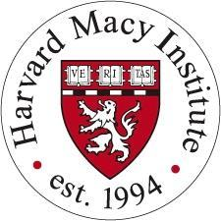
The Stuart J. Goldman Educator Award is given to a fellow who seeks to enhance their skills as an academic clinician-educator. Dr. Goldman was the fellowship director for over two decades, and strongly promoted the development and implementation of innovative teaching initiatives in the clinical setting. Dr. Goldman wholeheartedly encouraged the fellows to become independent, self-motivated, and self-directed learners and teachers. This annual award is given to recognize his lifelong commitment to training the next generation of child and adolescent psychiatric educators through attendance at the Harvard Macy Institute program. Any 2nd year fellow who is considering a career as a clinician-educator is eligible for this award.

The Harvard Macy Institute Program for Post-Graduate Trainees: Future Academic Clinicians is a three day, intensive program focused on two major themes: skills in teaching and learning, and developing scholarship in medical education. Learning formats rely on small group project work and problem solving, interactive group activities with individualized feedback, and large group case-based discussion. The course learning is built around the fellow’s educational project development. Accordingly, each fellow must apply with a medical education project that will benefit the current (or future) Boston Children’s Hospital CAP Fellowship training program. Scholars must have the explicit support of a faculty mentor who will assist and oversee the project development.

ADDITIONAL PROGRAM INFORMATION
Our 24-month program is fully accredited by the Accreditation Council for Graduate Medical Education (ACGME). Fellows in good standing will be eligible for specialty boards in Child and Adolescent Psychiatry providing they have met the other requirements as described by the Board.

APPOINTMENTS
Fellows are appointed to both Boston Children’s Hospital and Harvard Medical School.

SALARY
Effective July 2020, the following are BCH salaries respective to postgraduate level:
House Officer - PGY IV $79,200
House Officer - PGY V $84,700
House Officer - PGY VI $91,225

BENEFITS – HEALTH, MALPRACTICE AND OTHER INSURANCE
Fellows receive malpractice insurance coverage while serving patients at Boston Children’s Hospital. House officers may enroll in a variety of health insurance and health maintenance programs, dental insurance, disability insurance and life insurance are also provided.

HOUSING ASSISTANCE
Boston Children’s Hospital offers the Lease Guaranty Program, which is a program for salaried fellows that alleviates the outlay of security deposits, and first and last month’s rent payments, which are typical when renting a new apartment in Boston.

TRANSPORTATION/PARKING
Boston Children’s Hospital is convenient to various modes of public transportation (bus, commuter rail and subway), and also provides subsidies for monthly commuter passes, and discounted parking for house staff.

CHILD CARE CENTER
BCH manages a childcare center for the children of hospital employees. Hours of operation are 6:30am to 6:00pm, Monday through Friday, except for recognized holidays. The center accommodates 42 children, ages three months to five years. For more information about the program, or for a tour, please call (617) 355-6006.

VACATION
Fellows are offered twenty days of vacation time and five professional days during each year of training; timely notice is expected prior to taking time off. Absences during the first two months of training are strongly discouraged and require special permission from the Training Director.

EDUCATIONAL RESOURCES FOR TRAVEL
Each fellow receives a one-time $1,000 allowance to be used towards expenses for attendance at conferences. For fellows presenting posters, papers or abstracts, an additional annual allowance of $500 is available. We make it a priority for fellows to attend AACAP at least once during their fellowship.

APPLICATION PROCESS
Eligible applicants are graduates of American or international medical schools, have completed at least three years of a General Psychiatry or Pediatrics residency, and have passed USMLE steps 1 through 3. ECFMG certification is required for foreign medical graduates. Applications must include:
- a completed application form;
- Training Director’s letter of support;
- medical school transcript;
- USMLE scores;
- three letters of reference;
- curriculum vitae;
- personal statement.

All applicants must utilize the ERAS website: https://www.aamc.org/services/eras/

Foreign citizens who come to the United States for postgraduate training must comply with United States Immigration Laws, in addition to following the application procedure described above. Foreign medical school graduates should contact the Educational Commission for Foreign Medical Graduates for details concerning their requirements: 3624 Market Street, Philadelphia, PA 19104, 215-386-5900. BCH sponsors J1 visas.
Boston Children’s Hospital participates in the National Resident Matching Program and abides by all NRMP rules and regulations. Please note that all offers for fellowship positions are contingent upon the successful completion of all residency training, as well as all hospital required pre-employment matters. This includes the satisfactory completion of the credentialing process, and receipt of acceptable final evaluations and letters of references.

For inquiries, please contact:
Zheala Qayyum, MD, MMSc
Fellowship Training Director
Department of Psychiatry
Boston Children’s Hospital
300 Longwood Avenue
Boston, MA 02115 617-919-6954
zheala.qayyum@childrens.harvard.edu

For application questions, please contact:
Courtney S. Kellogg
Program Coordinator
Department of Psychiatry, Administrative Offices
Boston Children’s Hospital
300 Longwood Avenue
Boston, MA 02115 617-355-4563
courtney.kellogg@childrens.harvard.edu

OUR FACULTY
David R. DeMaso, MD ~ Psychiatrist-in-Chief
Patricia Ibeziako ~ Associate Chief for Clinical Services
Zheala Qayyum, MD ~ Training Director
Chase Samsel, MD ~ Associate Training Director

Outpatient Psychiatry Service Psychiatry Consultation Service

Oscar Bukstein, MD-Med. Director Chase Samsel, MD-Director
Charlotte Baillieul, NP Yasmin Cole-Lewis, PhD
Elisa Bronfman, PhD Serena Fernandes, MD
Devon Carroll, NP John Glazer, MD
Elisa Bronfman, PhD Emily Hall, MD
Marcus Cherry, PhD Kristine McKenna, PhD
Eugene D’Angelo, PhD Nina Muriel, MD (DFCI)
Joseph Gonzalez-Heydrich, MD Imari Palma, PhD
Hesham Hamoda, MD Kate Thomson, PhD
Aaron Hauptman, MD Kevin Tsang, PsyD
Colleen Hayden, LICSW
Shannon Hourigan, PhD Emergency Psychiatry Service
Roberta Isberg, MD Zheala Qayyum, MD-Director
Sonia Joy, MD Oscar Bukstein, MD, MPH
Tamar Katz, MD
Beth Kemler, PhD, MSW Martha Elliot Health Center
Jung Kim, MD Olivia Carrick, MD-Director
Erica Lee, PhD
Roxana Llerena-Quinn, PhD Adol. Substance Abuse Program
Lauren Mednick, PhD Diana Deister, MD
Kaizad Munshi, MD Sharon Levy, MD
Heather Potts, PhD Patricia Schram, MD
Keneisha Sinclair-McBride, PhD
Carolyn Snell, PhD
Elizabeth Wharff, PhD, LICSW Boston Children’s Hospital
Neighborhood Partnerships
Shella Dennery, PhD, LICSW-Director
Inpatient Psychiatry Service
Annemarie Caracansi, MD-Med. Director Community Based Acute Treatment
Yohanis Anglero Diaz, MD Claire Brickell, MD-Med. Director
Ethan Anglemyer, DO
Shaela Demers, LICSW Pediatric Neurology
William Hall, LCSW Sarah Spence, MD
Lauren View, LICSW David Urion, MD

Children’s Hospital Early Childhood &
Global Partnerships Program Neurodevelopmental Disorders

Patricia Ibeziako, MD, Senior Director Kerim Munir, MD
Myron Belfer, MD Joshua Sparrow, MD
Serena Fernandes, MD, Co-Director
Kevin Tsang, PsyD, Co-Director

Research – Program for Behavioral Science & Fuss Center

David Glahn, PhD-Director
Todd Anthony, PhD
William R. Beardslee, MD
Oscar G. Bukstein, MD, MPH
David R. DeMaso, MD
Eugene D’Angelo, PhD
Heidi Ellis, PhD
Michelle Bosquet Enlow, PhD
Joseph Gonzalez-Heydrich, MD
Christine Seiberg, PhD
Deborah Waber, PhD

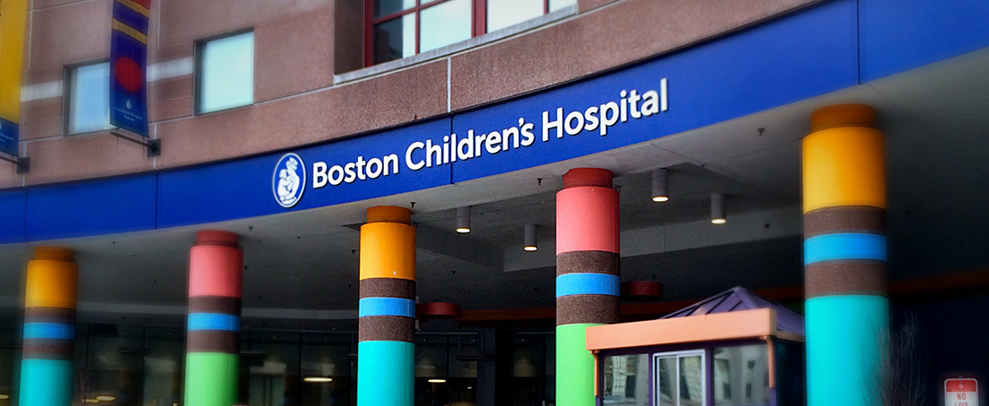

OUR CHILD & ADOLESCENT PSYCHIATRY FELLOWS

FIRST YEAR FELLOWS

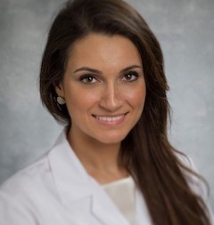 Mariam Aboukar, DO
Dr. Aboukar graduated from The Ohio State University with a Bachelor’s of Science in Nutritional Sciences and pursued medical school training at Ohio University’s Heritage College of Osteopathic Medicine, with a clerkship in psychiatry at the Cleveland Clinic - Abu Dhabi campus, exercising her Arabic-speaking skills. She completed graduate training in Transformational Leadership, Life Coaching and Emotional Intelligence at Wright Graduate University, where she was exposed to rigorous didactic and experiential personal development work and an integrative approach to psychotherapy. Her adult psychiatry residency was at AdvocateAurora Health Care system in Chicago, IL. She served as the Illinois Psychiatric Society (IPS) Resident-Fellow Member (RFM) Chair, IPS Council Member and APA Area IV Council Member, was named the Illinois State Resident of the Year of 2019 by IPS, and currently serves on the APA’s Committee Of Tellers. Dr. Aboukar served as a staff psychiatrist for The Khalil Center, the largest Muslim Mental Health Community Clinic, and serves as Director of Wellness and Chief Communications Officer for MEDspiration, a nonprofit organization aimed at promoting access to health literacy. She engaged in medical relief efforts through the UNHCR for the treatment of women and children in war-torn areas, including Syrian refugees, where she assisted in reporting for The Atlantic Monthly. She’s presented at the International Academy for Law and Mental Health Congress in Rome, Italy on Forensic Facets of Sexual Trafficking and Terror, Tactics, Trauma and Transformation: Islamophobia and The Mental Health Sequelae. Dr. Aboukar enjoys singing and yoga, and looks forward to working with children and adolescents.

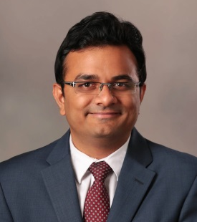 Zeeshan Mansuri, MD
Dr. Mansuri is originally from India and did his Master’s in Public Health specializing in Epidemiology and Bio-statistics from Drexel University, followed by a general psychiatry residency at Texas Tech University. He is very passionate about mentoring medical students and residents using Facebook as a platform to connect with them. With his belief that every person has a story to tell and a lesson to teach, he created a website called, “humansofusmle.org” to bring out inspiring stories and life lessons about physicians who go through the journey of USMLE (United States Medical Licensing Exam). Concerning research, he works on trying to understand the impact of psychiatric diseases on hospital outcomes for medical diseases by using nationally representative large datasets. During his free time, he loves to hang out with friends and play and watch tennis, cricket, and table tennis.

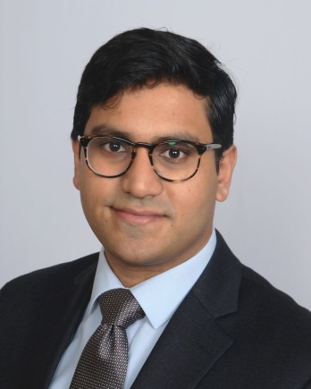 Saad Rahmat, MD
Dr. Saad Rahmat, M.D. grew up in Maputo, Mozambique and Columbia, Missouri. He continued his journey and attended New York University where he majored in History and minored in Mathematics and Chemistry. He worked in bench and clinical research at the Icahn School of Medicine Department of Microbiology for 3 years. Saad graduated from St. George’s University in Grenada and completed his general adult psychiatry residency at the Westchester Medical Center. He relishes the opportunity to teach medical students and won a Teaching Excellence Award during his residency. He continued to work on research during residency where he completed clinical research on PTSD in Level II trauma patients. Given his background, he has an interest in gaining a better understanding of psychiatric disorders, particularly psychosis, within immigrant families. He enjoys reading Star Wars Expanded University fiction, alliteration, and meandering through museums.​
Avaas Sharif, MD
Avaas Sharif was raised as a first generation Pakistani-American and spent his formative years in Central New Jersey. Legend has it, he was born with a beard and mustache. While completing his Undergraduate Degree in Biology with a minor in Africana Studies at Rutgers University in New Brunswick, NJ, Avaas also volunteered as an EMT. His next adventure brought him from the swift seasons of New Jersey to the soft sands of Sint Maarten for medical school. While enrolled at American University of the Caribbean in Sint Maarten, he operated an orphanage and foster care outreach program, which combined three of his passions: the beach, barbequed food, and working with the youth. He then returned to his native land, New Jersey, for residency in general psychiatry at Bergen New Bridge Medical Center. During that time, Avaas spearheaded a program to provide education on opioid use as well as free naloxone hydrochloride nasal spray for the care-takers and families of adolescent substance users within the community. Throughout residency, he continued to solidify his interests by focusing on working closely with the child and adolescent population in the inpatient, outpatient, and emergency room settings. One of the facets of residency Avaas enjoyed most was working with medical students and junior residents. He has a passion for teaching and hopes to one day work in medical education. When not at work or traveling the world in search for food and adventure, you can find Avaas schooling people of all ages on the basketball court.

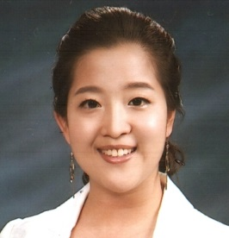 Ah Lahm Shin, MD
Dr. Ah Lahm Shin, M.D., was born and raised in Seoul, South Korea. She received her undergraduate degree with High Honor from Ewha Woman’s University in Seoul, South Korea with majors in clothing design and human development. She originally planned to pursue her career in children’s clothing industry; however, it did not take her long to find out about her strong interest in child development, which was when she started to dream about her career in medicine. In 2004, she co-founded an intercollegiate volunteering organization, called K.I.D.S. United, to serve the hospitalized children in children’s hospitals in Seoul metropolitan area, which currently has over 2500 registered members. She received her medical degree from Kyungpook National University School of Medicine, Daegu, South Korea and moved to Boston, where she worked as a research assistant at Boston VA and Boston Children’s Hospital. She completed her general adult psychiatry residency training at University of Alabama at Birmingham (UAB). She is interested in consult/liaison psychiatry, developmental disorders, cultural aspects of psychiatry, and physician wellness. Outside of work, she enjoys spending time with her family and crafty hobbies such as knitting, crocheting, cooking, baking, and painting. She is excited to be back in Boston, which she calls her second hometown.

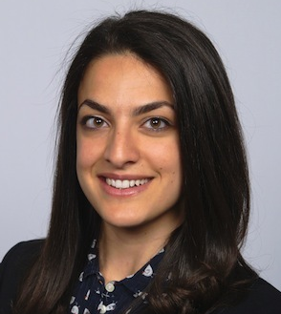 Stephanie Stramotas, MD
Dr. Stephanie Stramotas, MD, MPH was raised in a small coastal town in Los Angeles, CA. She attended the University of California, Berkeley, where she earned a Bachelor’s degree in Molecular & Cell Biology, with an emphasis in Neurobiology. To complement her studies of microbiology, she stayed at Berkeley to complete a Master’s degree in Public Health, specializing in Epidemiology and Biostatistics, which equipped her with a broader perspective of health and healthcare. As a graduate student, she taught Epidemiology and Neuroanatomy courses, conducted a meta-analysis on perinatal infection and risk of schizophrenia in the offspring, published articles on brain tumor epidemiology, lobbied as a patient advocate in Sacramento and Washington, D.C., studied as a Health Leadership Fellow, and served as the President of the American Medical Student Association, Berkeley pre-medical chapter for two consecutive years. She worked as a research analyst at the UCLA Center for Clinical AIDS Research and Education, where she co-authored publications on fertility intentions in HIV-infected men and women in Malawi as well as bench-work research. She then entered her medical training with the inaugural class at the University of California, Riverside School of Medicine, and returned home for her general psychiatry residency at the Los Angeles County + University of Southern California Medical Center. During residency, she served in numerous leadership positions and was recognized in 2019 with the Program Director’s Award. Her passion for understanding how food impacts health led her to study the use of a ketogenic diet for weight loss and treatment of psychosis in a patient with schizophrenia on clozapine, and she presented her results at the annual American Psychiatric Association meeting and at the Metabolic Health Summit. She is excited to be in Boston for her fellowship training, where she hopes to develop her understanding of child development, psychiatric pathology, and psychodynamic psychotherapy. Stephanie is a former professional, classically-trained singer, and enjoys hobbies including soccer, guitar, and barre training.

SECOND YEAR FELLOWS

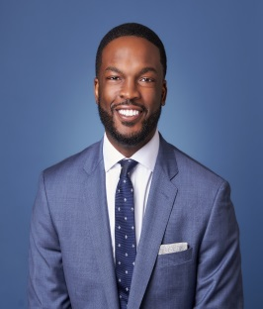

Kevin Simon, MD
Dr. Simon is originally from Brooklyn, NY. He earned his Medical Degree from Southern Illinois University School of Medicine; prior to graduating, he was awarded a research fellowship from the National Institute of Mental Health where he studied implementation of innovative health systems to improve mental health services for children. He completed his bachelor’s degree in Biology/Sociology at Morgan State University, and his adult psychiatry training at Morehouse School of Medicine. Kevin was a Group for the Advancement of Psychiatry (GAP) fellow and an American Psychiatry Association – Public Psychiatry Fellow. Dr. Simon has published in notable academic journals including Anti-Cancer Drugs, Health Affairs, Psychiatric Services, and Psychiatric Times; he’s contributed to policy briefs disseminated by The Kennedy Forum and written several book chapters. He’s fought for criminal justice through work with Physicians for Criminal Justice Reform. Dr. Simon’s career interest includes a hybrid of community mental health, organized psychiatry and advocacy.

Nadia Daly, MD, FRCP
Dr. Daly was born, raised, and lived her whole life in Montreal. She completed her
medical studies at McGill University, and is excited to join the team at Harvard (a
school known as “the McGill of the United States”). She is drawn to psychiatry for its
unique opportunity to delve into fascinating questions at the intersection of
developmental, behavioral, social, and pharmacological science. In addition to sitting on
various committees with the Canadian and American Psychiatric Associations, Dr. Daly
has organized multiple research conferences, and served as the editor of a Canada-
wide psychiatry newsletter for residents. She has conducted, presented, and published
research on such topics as mentoring and therapeutic alliance in psychiatric education,
global mental health, cultural psychiatry, body image, and refugee mental health. Her
enthusiasm for bringing people together has led her to organize (and win!) resident trivia
competitions, and promote participation in APA and CPA events. On her free time, Dr.
Daly is equally passionate about watercolor painting, skiing, and reading about
architectural styles and period furniture. As a good Montrealer, Dr. Daly is trilingual,
multicultural, and has gone on impromptu trips to over 20 countries on 4 continents. A
dog-lover and piano player, she considers herself an artiste manquée who found her
vocation in medicine’s most eclectic, far-reaching, and interesting field.
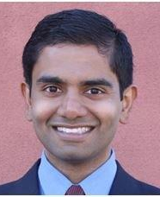 Vivek Jain, MD
Dr. Jain was born in India and came to the United States as a young child. He was raised in Southwestern Virginia, in the foothills of the Blue Ridge Mountains. He joins us after his residency in New York; he completed his undergraduate and medical education in Virginia. He’s super-excited to be in fellowship. His interests in psychiatry include neurodevelopment, psychotherapy, prevention, addiction and eating disorders, trauma, CL, and psycho-oncology. He is a fan of documentary films, gardening, reading, and trying his hand at making food.

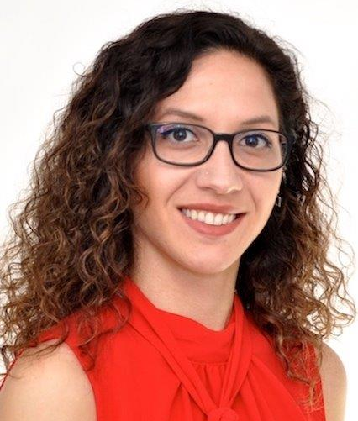 Sundus Mari, MD

Dr. Mari grew up between Germany and Jordan, both places she can call home. She graduated from Weill Cornell Medical College in Qatar and then matched into an Obstetrics/Gynecology residency in New York. Soon enough, she realized that it wasn’t the right field for her and then dedicated herself to becoming a psychiatrist. After spending a year in clinical research, she joined the local Harvard South Shore Psychiatry Residency Program in 2015. With an interest in psychotherapy, Dr. Mari completed a one-year fellowship in child psychoanalytic training at the Boston Psychoanalytic Society and Institute as well as the psychotherapy track in her fourth year at her adult residency program. During her residency, she was also actively engaged in mental health advocacy, particularly the annual NAMI walk; a tradition she hopes to carry with her to fellowship. Dr. Mari is interested in lifestyle medicine and physician wellness and she was part of a team that helped establish an annual wellness day at her residency program. In her spare time, Dr. Mari enjoys playing the piano, hiking and doing yoga. She also (finally) signed up for her 1st half-marathon this coming Fall and is about to finish knitting her first sweater. Always by her side you will find her adorable, feisty chiweenie (50/50 Dachshund/Chihuahua Mix) Miles, the cuddle-bug.

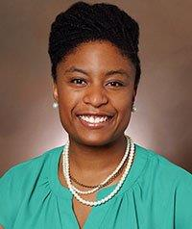 Bianca Busch, MD

Dr. Pullen was born and raised in the sunshine of the Mountain West. She earned a Bachelor of Arts in Human Development from the University of Chicago. Following her undergraduate studies, Dr. Pullen served families as a Public Health Nutritionist and completed an anti-hunger policy fellowship with the Congressional Hunger Center. She then pursued post-baccalaureate studies at the Harvard Extension School while working with an interdisciplinary pediatric team at Boston Medical Center. As a medical student at The University of Colorado School of Medicine, Dr. Pullen's persistent passion for health policy and justice was recognized with the Gold Humanism award. During her general psychiatry training at the University of Chicago, Dr. Pullen enjoyed teaching medical students, developed a passion for psychodynamic psychotherapy, served as a Resident-leader for the Illinois Psychiatric Society, and was named their 2018 Resident of the Year. When she is not working, she enjoys biking and spending time with her family. Dr. Pullen is excited to be at Boston Children's Hospital and is looking forward to rich mentorship and ongoing growth as a physician-advocate.

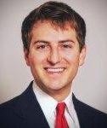 Nicholas Skefos, DO
Dr. Nicholas Skefos, D.O., grew up in Memphis, TN. He went on to attend Southern Methodist University (SMU) in Dallas, TX, where he received his B.A. in psychology with a minor in biology. During this time, he worked briefly as a research assistant, examining the effects of corporal punishment in children. During the summers, he volunteered at Paul Newman’s Double H Ranch, a camp for kids with serious and life threatening illnesses, in Lake Luzerne, NY. Following his undergraduate training, Dr. Skefos earned his medical degree from the Philadelphia College of Osteopathic Medicine (PCOM). After medical school, he went on to complete his general adult psychiatry residency training at the University of Alabama at Birmingham (UAB) Medical Center in the Department of Psychiatry & Behavioral Neurobiology. He and his wife are very excited to move to Boston and explore everything the city has to offer.

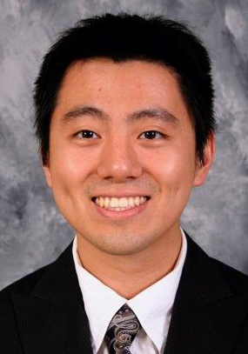 Yajie Yu, MD

Dr. Yu obtained his bachelor’s degrees in Psychology and Biology at Truman State University in Kirksville, MO, and later attended medical school in his home state of Missouri. Since moving to Boston for residency three years ago, Dr. Yu has been an active member of the Harvard Dragon Boat Team as well as MIT’s Pokémon League. He has always known that he wanted to work with kids and adolescents. He worked as a dorm adviser for college freshmen as well as high school summer camps. Dr. Yu wishes to do research about virtual reality and its effects on mental health in children and adolescents. Outside of work, Yajie and his spouse Heather live in Boston with their two cat children, Maslow and Belle. Yajie enjoys painting, exercising, cooking, and various nerdy hobbies.

OUR DEPARTMENT SERVICES AND PROGRAMS
Our Outpatient Psychiatry Service (OPS) offers comprehensive assessment and treatment services to children and their families on the Longwood Avenue Campus; services are also offered at the Martha Eliot Health Center, located in nearby Jamaica Plain, and in Boston Children’s Hospital’s Waltham campus. The department provides approximately 20,000 annual outpatient visits at Martha Eliot and the Waltham campus.
Using somatic and psychotherapies, OPS offers exceptional evidence-based care for children presenting with a full range of psychiatric disorders. The Outpatient Psychiatry Service has specific focus and expertise in the assessment and treatment of complex neuropsychiatric illness (autism and pre-pubertal psychosis), and in psychiatric illness in the presence of medical comorbidity (diabetes, congenital heart disease, cystic fibrosis, epilepsy). The service is organized into three areas: General Psychiatry, Medical Coping and Developmental Neuropsychiatry.
- General Psychiatry treats anxiety, depression, trauma, stress disorders;
- Medical Coping treats co-occurring medical and psychiatric disorders;
- Developmental Neuropsychiatry treats biologically-based neuropsychiatric disorders such as acute psychosis, autism, and ADHD.
The Center for Neuropsychology, a clinic within OPS, provides neuropsychological services to children with co-morbid medical and neurological diagnoses (e.g., tumors, seizures, traumatic brain injury).
Although OPS principally serves children from Boston communities and the commonwealth, the reputation of Boston Children’s Hospital brings children from around the country and world. This cultural and ethnic diversity is a unique strength for OPS, providing our fellows a crucial platform for critical diagnostic and formulation skills, as well as both somatic and psychotherapies.
The department operates an intensive Inpatient Psychiatry Service (IPS), a 16-bed inpatient med-psych unit, as well as our stepped-down facility, the Community-based Acute Residential Treatment unit (CbAT). IPS specializes in caring for patients struggling with depression, psychosis, anxiety, eating disorders, as well as those who may have co-existing medical illness. IPS offers a cornerstone experience where fellows learn the fundamental diagnostic and therapeutic skills to work with the most challenging youth in a structured interdisciplinary setting. Our CbAT is a 12-bed unit providing less restrictive care for children struggling with disabling illnesses.
Our Emergency Psychiatry Service (EPS) offers acute psychiatric assessment and disposition services on a 24/7 basis in the hospital’s emergency department. Our department provides emergency psychiatry services to over 1,000 children in crisis annually. The EPS is staffed by psychiatric social workers with support from psychology interns, psychiatry fellows, pediatric residents and resource specialists, all overseen by the attending psychiatrist on duty. Our EPS offers an important educational environment for understanding and managing acute mental health crises faced by children and adolescents.

The Psychiatry Consultation Service (PCS) provides state‐of‐the‐art pediatric psychosomatic services to children and families facing challenges related to inpatient medical and surgical hospitalizations. Based upon the Clinical Manual of Pediatric Psychosomatic Medicine (co-written by our Psychiatrist-in-Chief), faculty and trainees provide responsive clinical guideline-based diagnostic and treatment services to all in-house Boston Children’s Hospital medical and surgical wards, as well as to a variety of medical-surgical subspecialties including: Cardiology, Cystic Fibrosis, Critical Care Medicine, Gastroenterology, Hematology-Oncology (with the Dana Farber Cancer Institute), Pain Medicine, and Solid Organ Transplant programs. Consultation services provide critical learning experiences in the important core competencies of systems-based practice and interpersonal and communication skills.

CLINICAL CARE FOR CHILDREN IN PRIMARY AND SPECIALTY CARE
The integration of behavioral health care into the primary, and specialty, pediatric setting has long been a priority within our hospital.

In our Primary Care Clinic, the department and the Pediatric Physicians Organization at Children’s (PPOC) have partnered to run the Behavioral Health Integration Program (BHIP). The program delivers integrated behavioral health (BH) services in community‐based pediatric primary care practices throughout Massachusetts. The program is training primary care providers and medical home teams in BH integration, filling critical gaps in the workforce, contributing to workforce development, and fostering effective integration across the continuum of care.

PPOC/BCH Telepsychiatry Project was started in 2017 with a grant from the Health Policy Commission. Serving 6 PPOC practices, the Telepsychiatry Project offers face-to-face consultation as well as ongoing care to children and their families with limited access to specialty psychiatric care.

Martha Eliot Health Center (MEHC), located in Jamaica Plain, serves as a primary site for exposure for our fellows to community psychiatry, and the care of underserved youth. It was founded in the 1950s when Dr. Martha May Eliot, a Harvard University professor of maternal and child health, was asked to collaborate with the Boston Health Commissioner to create a pilot program that eventually became the center it is today. MECH provides medical and psychiatric care to mostly low-income families and runs outreach programs that address obesity, asthma, mental health and violence, among other issues. The department also has child psychiatrists embedded in other nearby Boston Children’s Hospital affiliated health centers.

In the Massachusetts Child Psychiatry Access Project (MCPAP), the department joined with other state academic psychiatry departments to provide child psychiatry services to Massachusetts pediatric practices. This innovative program of collaborative healthcare provides rapid telephone consultation to pediatricians as well as consultations, care coordination, and educational services. MCPAP has had high primary clinician and parent satisfaction rates while becoming a national model for increasing access to child mental health services.

Our department provides collaborative clinical and research behavioral health services in multidisciplinary specialty pediatric programs in departments across the hospital, to include: Adolescent Medicine, Anesthesia, Cardiology, Developmental Medicine, Neurology, Oncology, Otolaryngology, Orthopedics and Primary Care. There is also a strong collaboration between our department, the Developmental Medicine Center and Neurology forming a state-of-the-art Autism Spectrum Center. Our department provides oversight to these mental health clinicians to ensure patient safety and quality of mental health care.

CLINICAL CARE FOR CHILDREN IN SCHOOLS
In partnership and collaboration with our community, the Boston Children’s Hospital Neighborhood Partnerships (BCHNP) program has promoted the social, emotional and behavioral health of diverse youth and families for the past 16 years, through high quality, innovative, and culturally relevant clinical care, education and advocacy in Boston’s schools and community health centers where children and adolescents live and learn.

BCHNP’s school-based program includes partnerships with public schools in Boston, Hyde Park, Jamaica Plain, Roslindale, and West Roxbury, including elementary, K-8, middle, and high schools. In the 2017/2018 academic year, BCHNP provided clinical, early intervention and prevention/promotion services to over 1,000 students, and provided over 800 hours of training and consultation to school staff and families, including workshops to 249 school staff. Family engagement and education is a critical component of BCHNP’s work in schools.

In 2015, BCHNP expanded its efforts to build the behavioral health capacity of partner schools through its launch of a new innovation: the Clough Foundation Training and Access Project (TAP), which aims to address students’ social, emotional, and behavioral health needs by supporting the development of sustainable systems to meet these needs. TAP provides high quality training and consultation in social-emotional development and behavioral health to school professionals across a two-year partnership.

GLOBAL PARTNERSHIPS PROGRAM

REACHING AROUND THE WORLD
The Children’s Hospital Global Partnerships in Psychiatry (CHGPP) was established because of our commitment to prioritize mental health care for children and their families. The CHGPP Observership Program is designed for international physicians and psychologists who have an interest in child and adolescent mental health; the program provides exposure to child mental health policy, clinical programming and practices to help them better advocate when they return to their respective countries of origin. The program convenes symposia on selected topics of interest to the Harvard community at large. Our department’s faculty is involved in ongoing partnerships with mental health professionals and academicians from over 18 countries including: China, Costa Rica, Haiti, Finland, France, Norway, Sweden, The Netherlands, Nigeria, Rwanda, Somalia, Tanzania, and Turkey. These collaborations include initiatives to improve access to quality mental health care, establish school-based mental health programs, and provide preventive interventions to families at risk for depression. Our fellows have the opportunity to learn directly from our senior faculty, conduct research abroad as well as engage our international colleagues about the challenges of providing quality mental health care to children and families outside the United States.

ENSURING QUALITY OF CARE
With the landscape of healthcare always in flux, superior, evidence-based care has never been more important. Recognizing an opportunity, the department implemented a dedicated, quality improvement program for child and adolescent psychiatry. Our program, the Psychiatry Quality Program (PQP), has a designated administrator who works with clinical, education, research, and advocacy leaders to champion for the department’s strategic priorities.

RESEARCH – STRIVING FOR INNOVATION
Research has been a core of the department for over 60 years; and we currently support over 50 researchers and support staff that are engaged in scientific investigations. The majority of our department’s projects reflect successful collaborations with other hospitals, as well as local, regional, national and international affiliated institutions.
Program for Behavioral Science – Supporting Research and Innovation
All department research falls under the management of the Program for Behavioral Science, which works to promote, support, and enhance the department’s research efforts by:
- identifying and promoting innovative research;
- developing and supporting individual researchers;
- facilitating research collaborations outside the department;
- overseeing the pursuit and management of research funding;
- overseeing department research essentials with administration support, biostatistics, scientific review/quality, behavior science, and faculty support/development.

Current areas of research in our department include: Influencing Psychotic Dysconnectivity in African Americans, Early Psychosis Investigation, Imaging Genomics of the Aging Brain, Developmental Neuroscience, Developmental Psychopathology, Genetic Profiles of Structural Loss in Schizophrenia and the Effect of Rare Genetic Variants on Psychiatric Symptoms and Cognitive Ability to name but a few.

Areas and Centers of Research Excellence – Understanding the Brain
Two centers of research excellence have emerged in our department: one in Developmental Psychopathology and a second in Community Psychology.
- The Tommy Fuss Center for Neuropsychiatric Disease Research is a multifaceted program that integrates psychiatry, neuroscience, genetics, stem cell science, bioinformatics, and brain imaging. The ultimate goal is to unlock the genetics and biology of psychiatric disease, focusing on early detection, prevention, and intervention, in order to protect and treat the most vulnerable community of children and young adults. The Fuss Center aims to understand what causes developmental pathways to diverge into pathological versus healthy outcomes, and is researching drugs for new therapies, which will change the course of disease. David Glahn, PhD, our Associate Chief for Research, joined the department in November 2018 as the Director of the Program for Behavioral Science and the Fuss Center. His research aims to identify and characterize genes and environmental factors influencing risk for psychotic and affective disorders and their endophenotypes, as well as to specify genetic and environmental influences on normal variation of brain structure/function and cognitive ability. In his position, he is charged with promoting teaching and mentorship for young and future investigators.

- The Refugee Trauma and Resilience Center at Boston Children's Hospital is dedicated to understanding and promoting the healthy adjustment of refugee children and adolescents who have resettled in the United States. In partnership with refugee communities and agencies, the Center’s goal is to build prevention and intervention programs, conduct research, and develop resources to assist refugee families and service providers. Under the direction of Heidi Ellis, PhD, our fellows have an opportunity to participate in work with children and families who have been displaced as a result of war, civil unrest, terrorism, or natural disasters.

Research in our department has a number of independently funded investigations including:
1) Discovery of biomarkers in early child psychosis and those at risk. Joseph Gonzalez-Heydrich, MD
2) Impact of maternal trauma history on infant and child development. Michelle Bosquet Enlow, PhD
3) Novel interventions for suicidal youth. Elizabeth Wharff, LICSW, PhD/Kimberly O’Brien, LICSW, PhD
4) Preventive family interventions for childhood depression. William R. Beardslee, MD
5) Preclinical neurobiological investigation of neural circuits associated with stress and anxiety.
Todd Anthony, PhD
6) Identification of the roots of and risk factors for radicalization, extremism, violence, and terrorism within refugee communities.
Heidi Ellis, PhD
Collaborations and Partnerships
A hallmark of department research is the breadth of collaborative work. The majority of research projects involve partnerships with other in-house departments, community groups, and national and international institutions, sharing work ideas and mentoring support. Close partnerships exist amongst institutions within the greater Boston medical and academic communities including: Harvard Medical School, Harvard University, Broad Institute, Wyss Institute, Boston University School of Medicine, Dana Farber Cancer Institute, Massachusetts General Hospital, and Massachusetts Institute of Technology; as well as government and private institutions, including: the Department of Public Health and Department of Mental Health, Refugee & Immigrant Assistance Center, and the Boston Public School system.
Fellows who intend to pursue research in earnest are assigned faculty advisors who work directly with them to develop ideas for projects. Boston Children’s Hospital offers opportunities to trainees and faculty to enroll in basic or intermediate courses in clinical research design, biostatistics, and the use of statistical software packages through the Clinical Research Program and the Harvard Catalyst Program.

CHILD MENTAL HEALTH INITIATIVES – OUR ADVOCACY PROGRAM
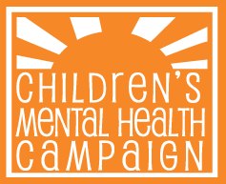
Our department has been, is, and will continue to be, a strong, active advocate for the highest quality mental health services locally, regionally and nationally. Utilizing public policy and community-based solutions, we work closely with our Government Affairs Office to partner with local groups, consumer advocates, healthcare providers, educators and policy makers to improve mental health services and access for children and families. Because we consider it important that our fellows be exposed to child mental health advocacy, we offer instruction in advocacy issues and efforts through seminars given by the Government Affairs staff. Additionally, we encourage fellows with specific interests in this area to participate in our ongoing advocacy efforts [e.g., Children’s Mental Health Campaign].

TRAINING FOR PSYCHOLOGISTS, SOCIAL WORKERS, & MEDICAL STUDENTS
For over 50 years, the department has provided training in child and adolescent psychiatry, clinical child psychology and psychiatric social work. We seek to provide superior education for mental health professionals, who can then aid in the development of child mental health policy, foster child mental health clinical programming and otherwise serve as advocates locally, regionally, nationally and internationally.

